**PRACTICAL-05**

**AIM**: - Connecting and extracting with various data resources in Tableau.

**THEORY**

Tableau offers a myriad of data sources such as local text files, MS Excel, PDFs, JSON or databases and servers like Tableau Server, MySQL Server, Microsoft SQL Server, etc. Categorically, there are two types of data sources that you can connect to in Tableau; **To a file** and **To a server**.

**STEPS**

1. For the Excel graph (sample_-superstore.xls), the sample data set for Super Store is being used. For representation of year (ship date) to sum of profit representing the region of people according to the different colours. It has parameters such as order ID, order date, product code, country, region, etc.
2. For the CSV graph (USA_housing.csv), the sample dataset used is USA housing, which represents the area according to the population and the sum of prices in that particular area. It talks about the dataset that can be used when considering buying a house and considers parameters such as the number of bedrooms, price, etc.
3. For JSON GRAPH (iris.json), this is the iris data set that revolves around the iris of a flower and has parameters such as petal length, width, sepal length, width, etc. This is to show the petal length in the count of petal lengths.

**RESULTS**

1. XLS Dataset Graph

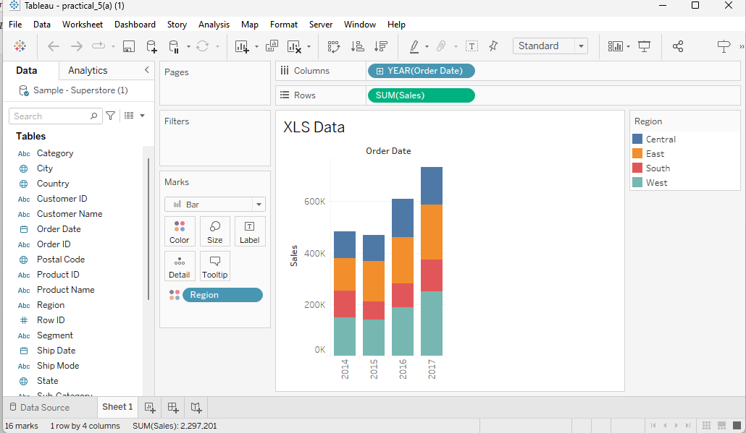

1. CSV data Graph

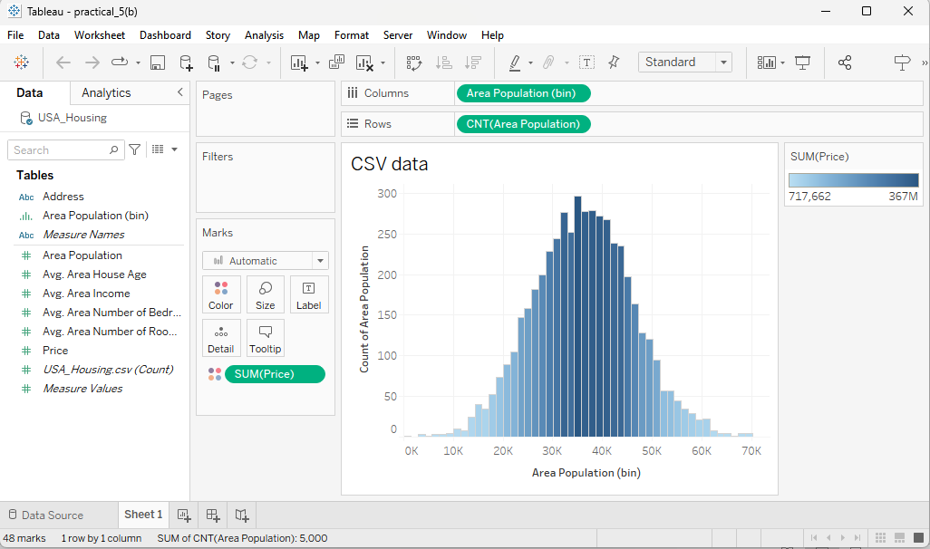

1. JSON Data Graph

